Cookies and Cream Cheesecakes

Ingredients:
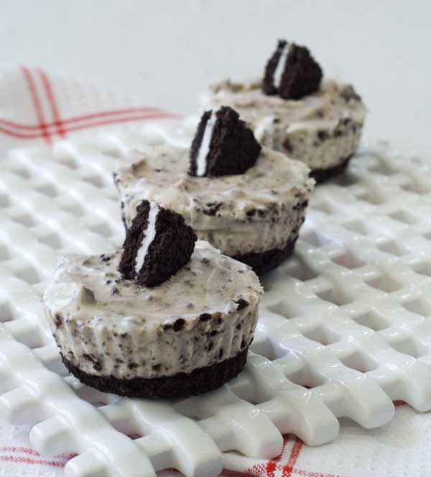
42 cream-filled chocolate sandwich cookies, such as Oreos, 30 left whole and 12 coarsely chopped
2 pounds cream cheese, room temperature
1 cup sugar
1 tsp pure vanilla extract
4 large eggs, room temperature, lightly beaten
1 cup sour cream
Pinch of salt

- Preheat oven to 275°F. Line standard muffin tins with paper lines. Place 1 whole cookie in the bottom of each lined cup
- With an electric mixer on medium-high speed, beat cream cheese until smooth, scraping down sides of bowl as needed. Gradually add sugar, and beat until combined. Beat in vanilla
- Drizzle eggs, a bit at a time, beating to combine and scraping down sides of bowl as needed. Beat in sour cream and salt. Stir in chopped cookies by hand
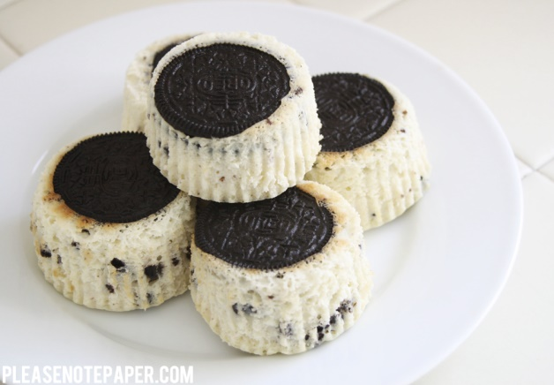
- Divide batter evenly among cookie-filled cups, filling each almost to the top. Bake, rotating tins halfway through, until filling is set, about 22 minutes. Transfer tinsto wire racks to cool completely. Refrigerate (in tins) at least 4 hours (or up to overnight). Remove from tins just before serving.

