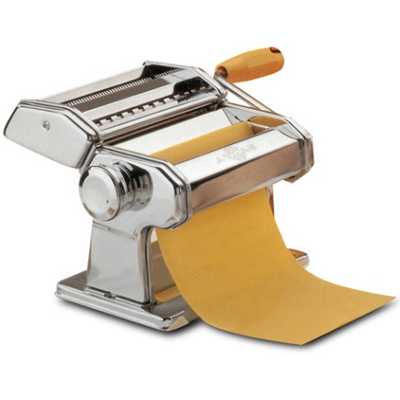
Fresh Pasta (with egg)
~250 mL unsifted all-purpose flour
1 egg
1 mL salt
3 mL vegetable oil

- Place egg, vegetable oil, and salt in a medium size mixing bowl and whisk until there are bubbles on the top surface
- GRADUALLY add 60 ml flour at a time and stir with a fork. Continue to add 60 ml of flour at a time until the mixture comes away from the sides of the bowl and is no longer sticky to the touch. (hint: you might need more than 250 mL flour in total).
- Turn dough onto a lightly floured surface and knead the dough until it is smooth and elastic. This should take about 5 minutes. (SHOW YOUR DOUGH TO THE TEACHER)
- Flatten the dough with your hand first. Dust with some flour on both sides.
- Adjust pasta machine to the widest setting. Using a pasta machine to roll out or flatten the dough. Fold once and roll again. Continue this setting until you hear the ‘pop’ sound.
- Make sure you sprinkle the dough with some flour between each flatten cycle.
Fettuccini Noodles:
- Once the dough is done in the widest cycle it should be smooth and elastic.
- Reduce the thickness accordingly of your pasta machine. Sprinkle some flour on the surfaces and roll over the past machine.
- Reduce machine to even thinner setting. Sprinkle dough with some flour and roll over the pasta machine.
- Once the dough is at its desired thickness, sprinkle with some flour again and divide into 12 inches length.
- To cut into noodles, sprinkle flattened dough with some flour. Position flattened noodle onto the cutter. Roll and catch the noodle underneath.
- Sprinkle the noodle with some flour. Let dry for a few minutes before forming a nest.
- Place 50 mL flour on a large plate. Place each nest on the plate (you should be able to form two nests). Freeze for 5 hours then store in a clean labelled Ziploc Bag.
