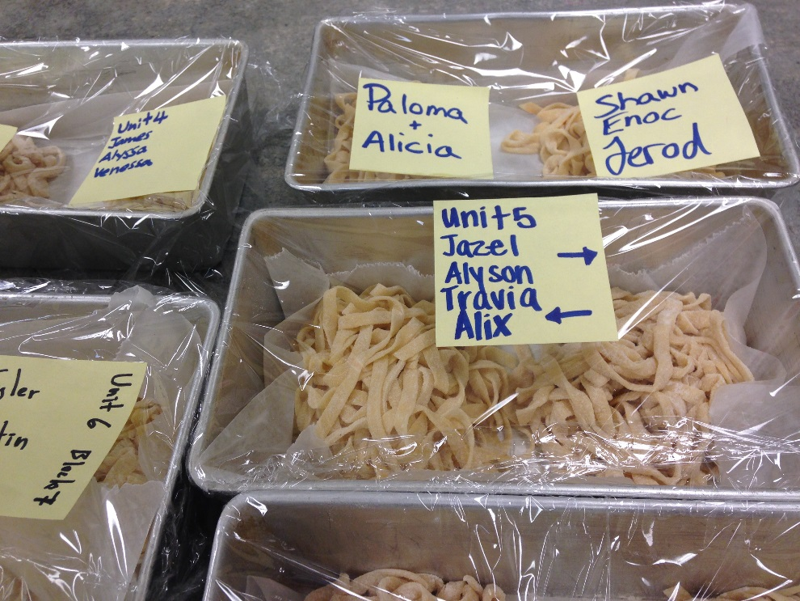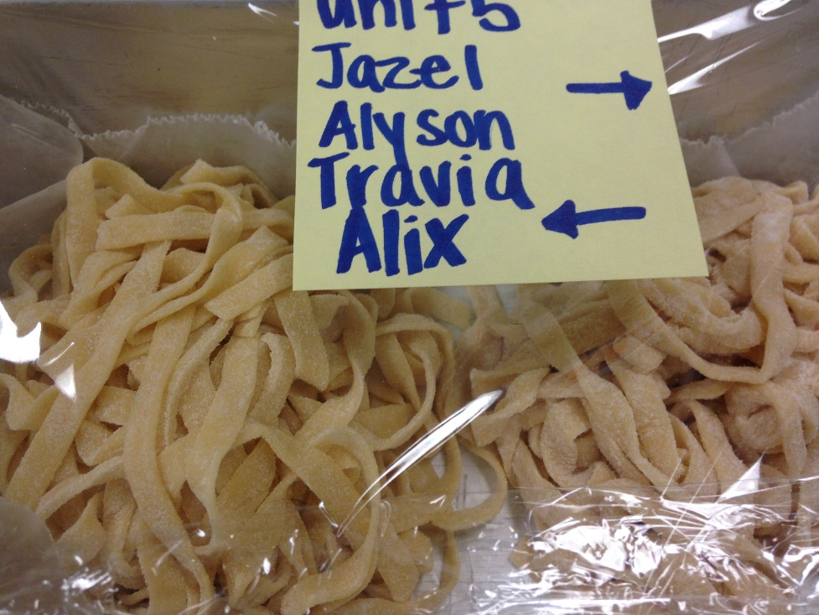

|  |  |  |
| --- | --- | --- |
|  |  | **Fresh Pasta and Bolognase Sauce**  Gr. 10/11/12 Food& Nutrition Class |