Growing Bean Sprouts In a Jar http://www.seriouseats.com/2011/04/how-to-grow-bean-sprouts-in-a-jar.html
- 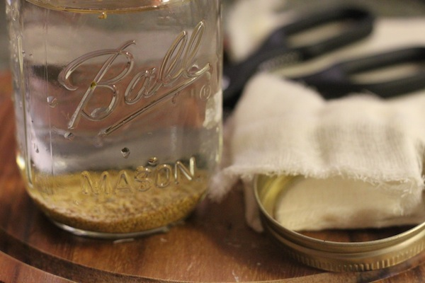

Place beans in jar with water
Fill the glass jar with cool, clean water. The beans will expand as they soak and take up even more space as they sprout, so give them plenty of space in the jar. Two tablespoons of alfalfa seeds for a 3-cup jar is plenty. Other beans should not take up more than ¼ of the jar.

- 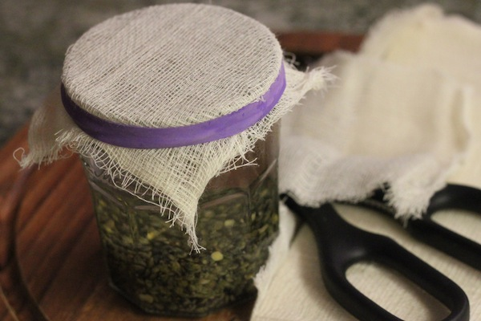

Soaking
Cover with a drainable cap and soak for 8 to 12 hours. Cheesecloth secured with a rubber band or the outer ring of a canning lid works well, though you can also buy special sprouting jars that come with a mesh cap.
Soak the beans for 8-12 hours at room temperature. A general rule of thumb: the larger the bean, the longer the soak.
- 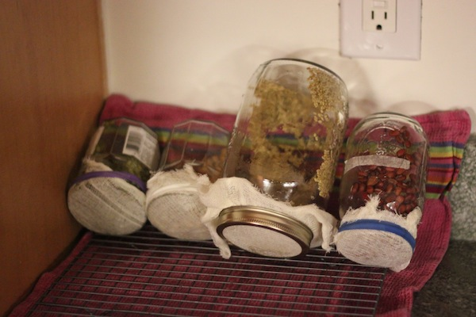

Rinse and drain
Drain the water out through the mesh cap. Give it a rinse with fresh water and drain again. Find a spot away from the sunlight. Place it upside-down at an angle on a dish rack or wire cooling rack so the remaining moisture is released through the opening of the jar. Make sure air can circulate around the opening.

Repeat
Rinse and drain the beans with fresh water at least twice a day, up to four times a day if the beans seem to be drying out completely.
Keep doing this until the sprouts grow to the length you want. Lentils and mung beans have been the fastest-growing in my experience – they just take a day or two after the initial soak. The whole process can take anywhere from 2 – 5 days. These lentils are just about done.

- 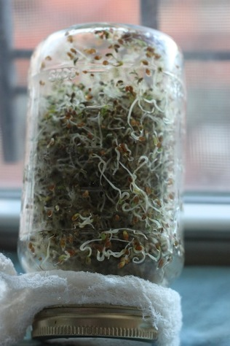

Final step for alfalfa
If you put a jar of sprouted alfalfa in a sunny window for a couple of hours, the tiny leaflets will develop some chlorophyll and turn green. Rinse in a large bowl of clean, cool water. Remove the hulls that float to the top.

- 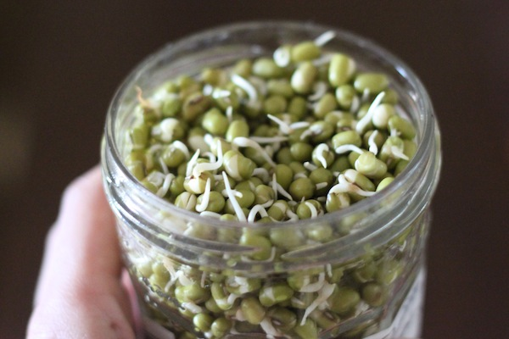

Wash and eat!
Give your sprouts a final rinse and drain them well in a colander before refrigerating. Sort out any unsprouted beans. Place them in a container or plastic bag lined with paper towel, seal, and refrigerate.
These sprouts are commonly eaten raw, but with the exception of alfalfa sprouts (which would turn to mush if cooked), other sprouted beans can withstand the heat. Mung bean sprouts can be added into a dish in the final two minutes of cooking. Sprouted lentils are fully cooked after 4-5 minutes of steaming. Sprouted chickpeas and adzuki beans need around 15 minutes of cooking.

