One Bowl Brownies
(Curtesy of Rachael Ray http://www.rachaelraymag.com/recipe/fudgy-one-pot-brownies/)

___________ mL  ___________ mL  ___________ mL  ______________  ____1 egg______  ___________ mL  ___________ mL | ¼ cup margarine  ½ cup + 1 Tablespoon white sugar  ½ teaspoon vanilla  f.g. salt  1 egg  ¼ cup unsweetened cocoa powder  1 Tablespoon + 2 teaspoons un-sifted all-purpose flour
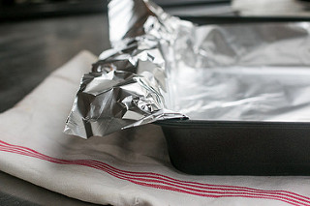
- Preheat oven to 350 F.

- Line a small loaf pan with foil. Leave a 2-inch overhang from the sides (it’ll be easier for you to remove the baked brownies)

- Grease the surface of the foil with shortening.

- In a small saucepan, melt margarine over medium low heat (#4). Stir in sugar, vanilla, and salt. Stir until mixture appears light a creamy paste.
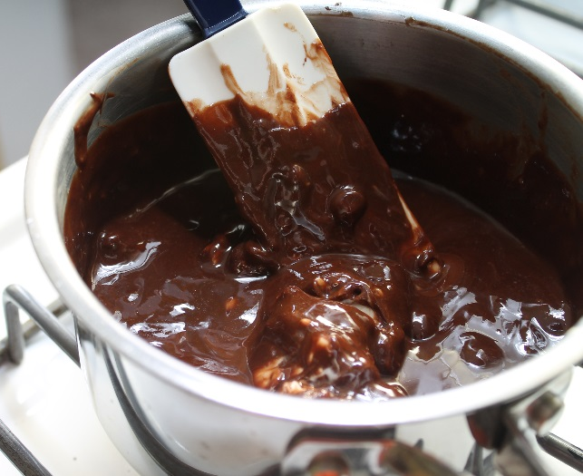
- Remove saucepan from heat. Vigorously beat the margarine mixture for another 1 minute to cool down slightly. Add egg and blend well.

- Add cocoa powder in. Stir until smooth, then add measured flour. Stir just blended.

- Transfer batter into prepared loaf pan. Bake for 25-30 minutes or until surface of brownies springs back when gently touched.

- Cool in the pan for additional 10 minutes. Use the foil overhang to lift the brownies out of the pan. Cut and serve.

