Bolognese Sauce Ragù alla Bolognese (recipe for the whole group)
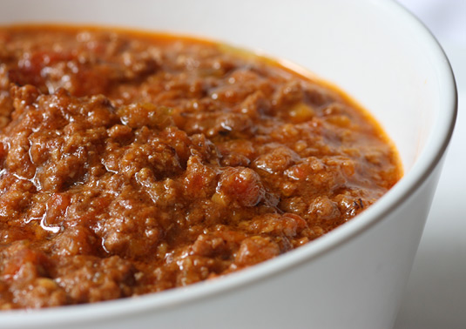

1 bacon, chopped coarsely
200 grams ground beef
½ medium onion, chopped
1 clove of garlic, minced
½ carrot, peeled and chopped
½ celery stalk, chopped
250 mL diced canned tomatoes
2 mL dried oregano
1 mL dried rosemary
1 dried bay leaf
50 mL cooking wine (white or red)
125 mL tomato sauce or crushed tomato
125 mL stock (or 125 mL hot water + 5 mL stock powder)
Salt and pepper to taste
15 mL Parmesan cheese- for garnish

Method:
- Cut bacon and prepare all vegetables.
- In a large pot, preheat pot with medium heat setting (#5). Place bacon in and cook until golden (about 2 minutes). If use chicken bacon, use 15 mL during cooking
- Reduce heat to medium-low (#3) add in chopped onion, minced garlic, chopped carrot, and chopped celery. Sauté for 3 minutes until vegetables are soften.
- Increase heat to medium high (#7). Add ground beef in to the pot. Cook until there is no pink showing.
- Add dried oregano, rosemary, and bay leaf. Stir in cooking wine, tomato sauce, diced canned tomato and stock. Use high heat to bring to a boil.
- Reduce the heat and allow the sauce to simmer for 20 minutes with the lid off. Stir occasionally to prevent sticking. If the sauce gets too thick, add in more stock or water.
(Suggestion: if you have more time at home, let the sauce simmer for 1 hour for deeper/ richer flavor)
- Just when the sauce is almost ready, season with salt and pepper.
- Serve the sauce over cooked pasta and garnish with a little grated Parmesan cheese.

Bolognese sauce is an Italian meat-based sauce for pasta which originates in Bologna, a city in Northern Italy. A thick, full-bodied meat sauce that's a staple of northern Italy's Bologna. A true Bolognese sauce includes a small amount of tomatoes or tomato paste in a rich sauce with meat and other ingredients. It tends to be served on thick pasta, as larger pasta shapes hold meat much better than finer pastas.

